2. Industry Analysis
This chapter frames the industry backdrop against which the Sun Pharma–Organon transaction must be judged. The central question is whether Organon’s asset base sits in structurally attractive markets, and whether the combined entity is positioned to compete. The short answer: Organon straddles three very different markets — a large but slow-growing global pharma market, an attractive women’s-health niche, and a fast-growing biosimilars segment — while carrying most of its revenue in a fourth, structurally declining pool of off-patent established brands. The industry logic of the deal is consolidation for scale and cost leadership in a margin-pressured industry.

2.1 Global pharmaceutical industry
The global pharmaceutical market was worth roughly US$1.77 trillion in 2025 and is forecast to reach US$3.2 trillion by 2035, a CAGR of ~6.1% (Precedence Research; corroborated by Grand View Research at US$1,738bn in 2025 growing to US$2,777bn by 2033 at 6.1%). Growth is driven by ageing demographics, rising chronic-disease burden, expanding healthcare access in emerging markets, and continued biopharmaceutical innovation.
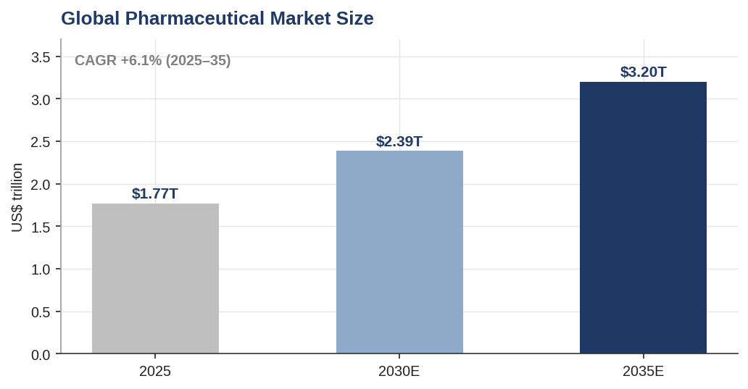
Global pharmaceutical market size and trajectory
Crucially for this deal, growth is not evenly distributed. The “pharmerging” markets (large emerging economies including India, China, Brazil) are growing far faster — Mordor Intelligence puts pharmerging growth at a ~9.66% CAGR to ~US$3.45 trillion by 2030, roughly 1.5–2x the developed-market rate. This matters because Sun Pharma is a low-cost, emerging-market-anchored manufacturer with deep distribution across exactly these geographies. The strategic reading is that Sun can push Organon’s mature branded portfolio through higher-growth emerging-market channels while extracting the manufacturing cost advantage that a US-centric spin-off like Organon lacks. The developed-market portion — where Organon earns most of its revenue — is the slower-growing, more price-pressured half of the market.

2.2 Women’s health market — the strategic jewel
Women’s health is the segment that makes Organon strategically distinctive. The global women’s-health market was approximately US$53–59 billion in 2025 and is forecast to reach ~US$68.5 billion by 2030, a CAGR of ~5.1% (Grand View Research), with longer-dated estimates of US$91–107 billion by 2035. Contraceptives are the single largest application, at ~35% of market revenue, driven by rising family-planning awareness and device innovation — and contraception (notably the Nexplanon/Implanon long-acting reversible franchise) is precisely where Organon leads. Asia-Pacific is the fastest-growing region, again playing to Sun’s distribution strengths.
The investment implication: women’s health gives the combined entity a defensible, branded, moderate-growth franchise with real pricing power and high barriers to substitution — the highest-quality piece of Organon’s revenue base, even though it is not the largest.
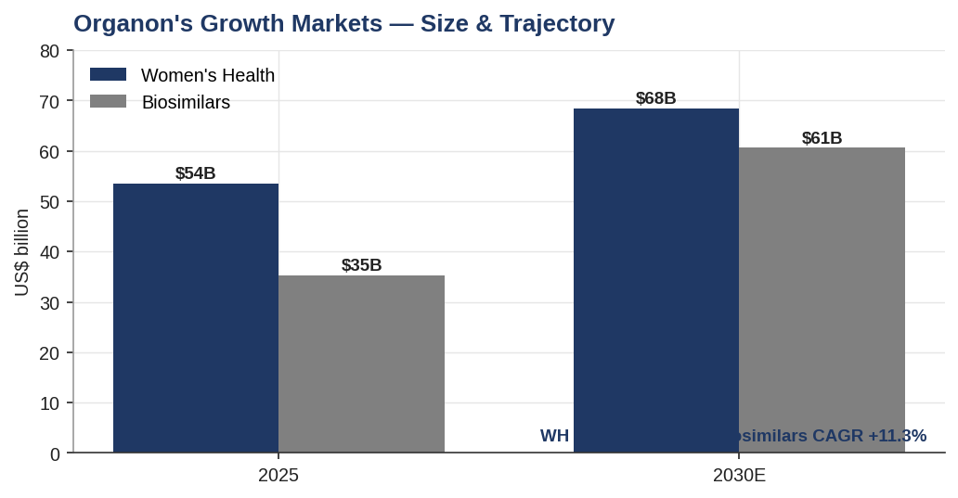
Organon’s growth markets — size and trajectory

2.3 Biosimilars — the growth option
Biosimilars are the fastest-growing market Organon touches. Estimates for 2025 cluster around US$35–42 billion, growing to ~US$60.6 billion by 2030 at an ~11.3% CAGR (Research and Markets), with more bullish houses (Mordor) modelling up to US$97 billion by 2030 at ~18% CAGR. Monoclonal antibodies represent ~41% of biosimilar revenue. Europe holds ~37% share, reflecting its early, clear regulatory framework, while Asia-Pacific posts the highest regional CAGR (~24%).
Biosimilars are the second pillar of the deal’s growth narrative and directly underpin Sun’s stated goal of becoming a top-10 global biosimilars player. The segment is capital- and expertise-intensive, so acquiring Organon’s existing platform is far faster than building one organically. The caveat is that biosimilars are inherently a price-erosion business — savings to the healthcare system come from competition, so margins compress as more entrants arrive; scale and manufacturing cost (Sun’s advantage) are the determinants of who wins.

2.4 Established brands & the patent landscape — the structural drag
The largest single slice of Organon’s revenue — ~US$3.7bn, ~60% of the total — sits in Established Brands: off-patent, branded, mature products. These generate strong cash flow with low reinvestment needs, which is what makes the deleveraging thesis credible. But they are in structural, secular decline: once a drug loses exclusivity, generic and biosimilar competition erodes both volume and price over time. The ongoing wave of patent expirations (loss-of-exclusivity, “LOE”) across the industry — with well over US$200bn of branded sales facing LOE through 2030 — is simultaneously the source of the biosimilars opportunity and the cause of Established Brands’ erosion. Organon is on both sides of that trade.
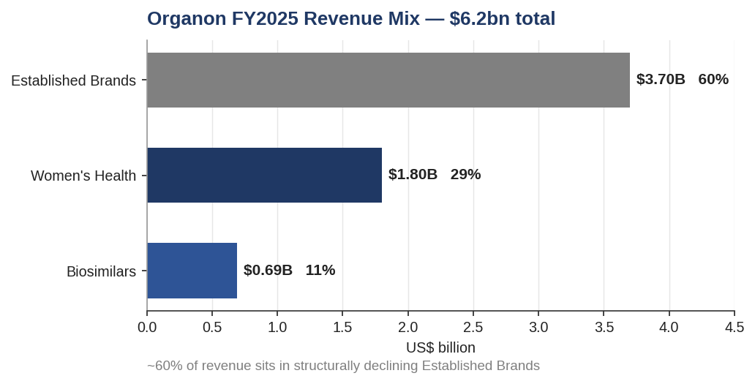
Organon FY2025 revenue mix by segment
The chart above is the single most important industry fact for the deal: the growth markets (Women’s Health, Biosimilars) are the smaller ~40% of Organon, while ~60% of revenue is exposed to secular decline. The entire investment case rests on whether the growing 40% can outrun the shrinking 60% fast enough to protect the EBITDA that services the acquisition debt.

2.5 Where the growth is
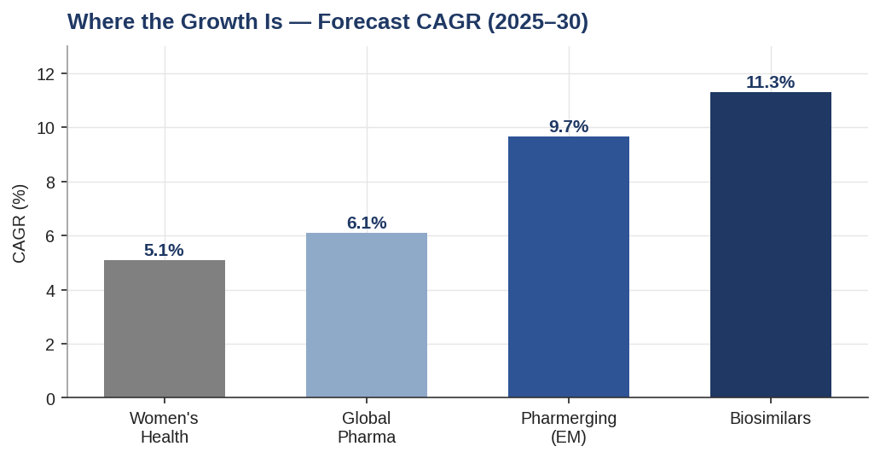
Forecast CAGR by segment
Ranked by forecast growth: biosimilars (~11.3%) and emerging markets (~9.7%) are the engines; the broad pharma market (~6.1%) and women’s health (~5.1%) are steady; established brands are flat-to-declining. A combined Sun–Organon is therefore a barbell: a large, cash-generative but declining base, plus two smaller, faster-growing franchises — with Sun’s emerging-market distribution and low-cost manufacturing as the lever that can tilt the mix toward the growth end.

2.6 Key industry trends
- Payer and government price pressure. US drug-pricing reform (the Inflation Reduction Act’s Medicare negotiation), European tenders, and emerging-market price controls compress branded pricing — the primary headwind for Established Brands.
- Biosimilar mainstreaming. Regulatory harmonisation and payer preference for lower-cost biologics are accelerating biosimilar adoption, especially in monoclonal antibodies.
- Emerging-market shift. Volume growth is migrating to pharmerging economies, favouring low-cost, distribution-rich players.
- Consolidation for scale. Margin pressure is driving M&A as companies seek cost leadership, portfolio diversification, and manufacturing scale — the macro rationale for this very deal.
- Vertical integration / supply security. Control of API and manufacturing (a Sun strength) is increasingly a competitive moat amid supply-chain and pricing pressure.

2.7 Porter’s Five Forces — global pharma (deal context)
Force | Intensity | Rationale
Threat of new entrants | Low–Moderate | High R&D cost, regulatory barriers, and capital intensity protect innovators; but the off-patent generic/biosimilar space has structurally lower entry barriers, intensifying competition in exactly Organon’s Established Brands pool.
Bargaining power of buyers | High (rising) | Payers, PBMs and governments (IRA, tenders) exert growing downward pressure on branded pricing — the central margin threat to mature portfolios.
Bargaining power of suppliers | Low–Moderate | API suppliers and CDMOs have limited leverage over large, vertically integrated players; Sun’s own API integration further neutralises this force.
Threat of substitutes | Moderate–High | Generics and biosimilars directly substitute originator products post-LOE; therapeutic alternatives add pressure. This is the force actively eroding Established Brands.
Competitive rivalry | High | A fragmented generics/biosimilars landscape with aggressive price competition and low switching costs; scale and cost leadership are decisive.
Net read: a mature, margin-pressured industry in which scale, cost leadership and portfolio diversification are the winning attributes — precisely the logic Sun is pursuing by acquiring Organon.

2.8 Competitive positioning
Sun Pharma is India’s largest pharmaceutical company and among the world’s largest generics/specialty players, with a strong US generics and specialty franchise (e.g., Ilumya, Winlevi, Cequa), deep emerging-market distribution, and low-cost, API-integrated manufacturing. Organon is a mid-cap Merck spin-off with a leading global women’s-health franchise, an emerging biosimilars platform, and a large established-brands portfolio, but a US-centric cost base and a levered balance sheet.
The relevant peer set for valuation and positioning includes Viatris, Teva, Sandoz, Hikma, Dr Reddy’s, Cipla and Lupin — diversified generics/specialty companies with comparable exposure to off-patent brands and biosimilars. Structurally, the closest analogue to the combination is the formation of Viatris (Mylan + Upjohn): a spin-merge that paired a generics manufacturer with a portfolio of mature branded drugs — a precedent both for the strategic logic and for the market’s scepticism about declining-asset roll-ups (a useful cautionary comp for the valuation and risk chapters).

2.9 SWOT — the combined entity / deal context
Strengths | Weaknesses
Combined scale (~$12.4bn revenue, top-25 global pharma); Sun’s low-cost, API-integrated manufacturing; Organon’s US commercial infrastructure and leading women’s-health franchise; top-10 biosimilars platform; strong aggregate cash generation. | ~60% of Organon revenue in structurally declining Established Brands; high post-deal leverage (~2.3x) vs Sun’s historic net-cash conservatism; USD/EUR debt vs partly INR/EM cash-flow mismatch; complex cross-border integration.
Opportunities | Threats
Cross-sell Organon’s brands through Sun’s emerging-market distribution; scale the biosimilars pipeline; deleverage via Established Brands’ free cash flow; tax/financing structuring efficiencies; deeper US-market presence. | US drug-pricing reform (IRA) and global payer pressure; biosimilar price erosion; patent litigation; multi-jurisdiction antitrust/regulatory risk; refinancing/rate risk on the acquisition bridge; currency volatility.

2.10 Chapter conclusion
The industry backdrop is mixed but coherent with the deal’s logic. Organon operates in two genuinely attractive markets (women’s health, biosimilars) but earns the majority of its money in a declining one (established brands). In a margin-pressured, consolidating industry, the acquirer that wins is the one with scale and the lowest cost of manufacturing and distribution — which is Sun’s structural advantage. The industry therefore supports the strategic rationale, while simultaneously flagging the core risk the rest of the report must quantify: the race between the growing 40% and the declining 60% of Organon’s revenue.

Assumptions, definitions & sources
- Market-size and CAGR figures are third-party research estimates and vary by provider and by market definition; each figure is attributed to a named source and used for framing, not as model inputs. Where sources conflict, a single internally consistent set is used per market (Precedence/Grand View for global pharma; Grand View for women’s health; Research and Markets for biosimilars) and the range is noted.
- Women’s-health 2025 base (~$53.5bn) is back-solved from Grand View’s 2030 figure of $68.53bn at the stated 5.1% CAGR for internal consistency; other providers cite a higher 2025 base (~$59bn) on a broader definition.
- Organon segment revenues (Established Brands $3.7bn, Women’s Health $1.8bn, Biosimilars $0.69bn) are FY2025 reported figures; total ties to $6.2bn.
- “Pharmerging” and total-market figures are drawn from different providers and are not additive.
Sources: Precedence Research; Grand View Research; Mordor Intelligence; Research and Markets — global pharmaceutical, women’s health, and biosimilars market reports (2025–2026). Organon Q4/FY2025 results for segment revenue. Full sourcing map in 05_Data/DATA_SOURCES.docx.

